
MITPlayer tools: Create an MITPlayer database
from ID3 tags in a music collection

Many groups have music collections containing data in their ID3 tags. A common convention is that Country information is placed in the Genre field, Choreographer or Teacher in the Artist/Composer field, and Title shows how the track should be displayed. If your music collection is organized at all like this fashion, you're in luck! A lot of time-consuming aspects of developing the MITPlayer's database (db) will be done for you. The program described here has lots of options that can create an initial db from scratch, or to merge the tags in new selections of music with an existing db.
Huge kudos to Steve Clarke for writing, rewriting and extensively growing the functionality of his CopyToMIT macro.
Document Organization
This doc explains the steps necessary to convert your music collection's tags to the MITPlayer db format.
Read also the section on preparing the Player's initialization file. We explain some of the fancier aspects of the macro's processes and control you have over its options.
Steps to Convert ID3 music tags to your MITPlayer db
You will 1) install the free mp3tag program; 2) modify mp3tag's output format; 3) run mp3tag; 4) run a macro within an Excel file; 5) rename the macro's output as your new MITPlayer db. Error checking and problems are documented by the macro. Although this process might look complicated, if there are no errors to correct, it will only take a few minutes.

1) Install the mp3tag program from here. mp3tag reads the ID3 tags in your music collection. It's free for Windows. (Macs have a 7-day free trial, which is more than you'll need.)

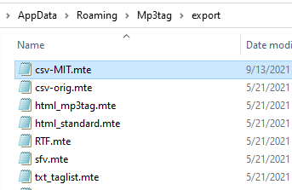
2) Modify mp3tag's default format for exporting data. Depending on what download setting you used, export formats
are stored in the directory at %AppData%\Mp3tag\export or %USERPROFILE%\Mp3tag\export
Rename the csv.mte you find there as csv-orig.mte.

Download our format file csv-MIT.mte from the
MITPlayer site – shown as Formatter under "Music collection
with extensive MP3/ID3 tags", and store it in the same directory.
(It will download with the extension xyz. Change that to mte.)

3) Start mp3tag. Navigate to open the topmost folder where your dances are located.

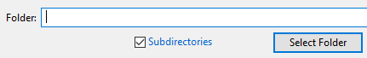
- Click to include subdirectories:

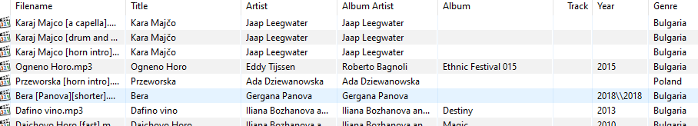
- The program will show your collection with its tags:

- Select All [Cntl-A] to highlight all your files. Then click File/Export [Cntl-E]. Do not export data without installing the
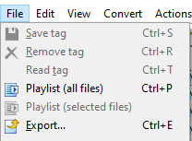
csv-MIT.mte format file mentioned above.

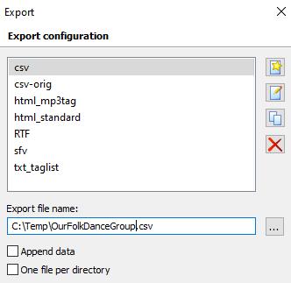
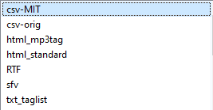

- Select csv-MIT and the location and name of your export file.

- Note the folder where you write the exported csv file.

4) Run the MITdb_Macro.xlsm obtained from the MITPlayer site (If download has .xyz extension, change to .xlsm)
[Don't have access to Windows Office programs? Send the two files (id3.tags.csv and your prior db) to Murray]

- If you received the Excel file by download or email,
the first time you run it you will get a security warning.
Click: Enable Content

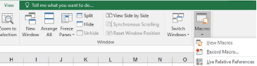
- Click (1) View, click (2) Macros, then (3) View Macros
3

2

1

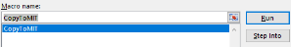
- Click Run after selecting CopyToMIT

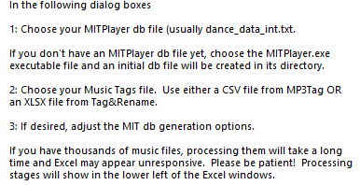

- An information box will pop up. It explains the steps to run the macro.
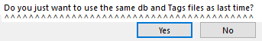
If you previously used the macro, a question will ask if you want to use the same two files [requested in the following dialog boxes] as the last time the macro was run. If so,
click Yes.

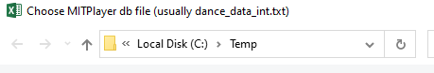
- IF you already have an MITPlayer db:
Navigate to the location of your exisiting db, select it and hit OK.
- IF you do not yet have an MITPlayer database:
Navigate to the location of the MITPlayer program executable, and hit OK.
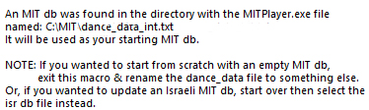
(If there is a db file in the selected directory, the macro will find it and offer to use it. If you instead want to start with a blank file, or the "isr" db, restart the macro following the instructions shown.)


- Now navigate to the CSV file with your ID3 tag info, the result of step #3, and select the file.

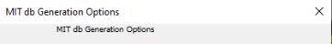
- Finally, a box will allow choosing your options for generating the db.
The options are described in detail in the Macro Processing Details section below – read that now. Choose your selections and hit OK.
Note: the macro remembers the options selected during its prior run; these become your (new) default options. Of course, you can choose different options.
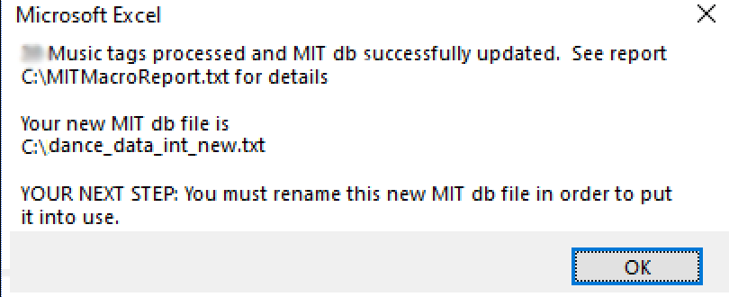
The macro will analyze the files and create a merged db file (with the name
"…new.txt") for you to use. If you have thousands of files in your collection, processing may take several minutes to finish. A summary will pop up.
If there are errors, details will be shown in the MITMacroReport.txt file.
[See Handling Errors below, before doing the next step]

5) Prior to installing your new db, backup your old database. You can do this manually in the File Explorer, or start the Player and use the Player's File/Backup [Cntl-B] function. Finally, before installing the new db, you must stop the Player.
Copy the new db file shown in the summary box and put it in the Player's Main directory, renaming it to remove the _new suffix. The newly created dance_data_int.txt (or dance_data_isr.txt) is your updated db file for the Player.
Run the Player's Utilities/Recheck Database [Cntl-R] to update the duration data with the precision used by the MITPlayer. Update as much information as you like for your music files: dance type, dance difficulty, preferred version, etc.

This is a Fresh Start / We've never had an MITPlayer db before / We're starting from the ID3 tags in our Music Collection
- Do all the initial setup steps described in the New Users documentation to set up the Player from the MITPlayer page.
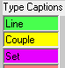
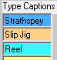
- Recommended: If your group has a majority dance type (eg, Line, Couple, Strathspey), list that as the first Type Caption on your Options/Setup Screen [Cntl-I]. The database created from your ID3 tags will all show that first type category. Over time, you can recategorize the smaller minority of your dance repertoire.

Handling Errors / My Run of the MITdb Macro Showed Errors
The MITMacroReport.txt file explains any errors that were found. Most will likely caused by letters containing unsupported accents. Every one of those characters will show in the database (and the Report file) as question marks (the original name is also shown in the Report file), eg Bučimiš will show as Bu?imiš, Čoček → ?o?eck,
Belčo Stanev → Bel?o Stanev, Ercument Kılıč → Ercument K?l??.
What you need to do: Respell the music files/choreographers using their unaccented equivalents. Depending on your reliance on accented letters, this may not be a large task. We developed the tool at this link to provide suggested
re-spellings. After fixing the files, rerun mp3tag and the Excel macro (Steps 3 and 4) to regenerate a corrected db.

Macro Processing Details
- Data Merges
The macro merges any new tag information with your existing db. That is, when it finds the exact same filename+path
in both files, the macro checks if the existing db was missing the country, choreographer or comment. If so, it takes the appropriate tag (e.g. genre, album artist, comment) following your option choices, and adds it to the Player db. Depending on your options, your db values for year and display name can also be updated.
For new music not already in your db, it takes the filename, path, genre, artist, comment, duration, year and display name from the tags and populates the appropriate fields in the Player db. This step is controlled by the selection of options when the macro first starts.
- Fancy stuff
If two or more display names are duplicated, the macro adds its own duplicate tag, eg Arap#02, Arap#03, …
If the title tag is missing, the macro derives the display name from the music file's name.
The macro attempts to remove unnecessary info in the display name, such as "Track 12" or "cdr 14", Obvious track numbers "03 Arap" or "08-Lingering Blues" are also stripped out. This algorithm isn't perfect, because it must avoid disturbing titles such as 16 Tons and 5 Figure Cacak.
Some users append the country to the filename or title, as in "Itele - Romania" or "Raca (Serbia)". If the genre tag is blank, these country names, and a few regional labels, are applied to the country field.
If the genre tag is blank, the country is assigned "Mars," as that is the Player's default for dragged-in dances

- Options
Options are explained in detail on next page.

- Options descriptions
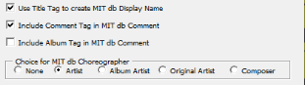

The first set of options control which tags (title, comment, artist, album artist, etc) are written to appropriate fields
in the db. If Title Tag is not selected, the display name is derived from the music file name. If both Comment Tag and Album Tag are set, both are included in the comment field, separated by a backslash. You have a choice of four different tag fields to use in populating choreographer, or you can choose to leave this field blank.
Remove country name from display name: By default (unchecked), the macro will remove leading zeros. These are usually track numbers, as in 03 Miserlou, 08 Erev Ba, which you do not want in your display names. If checked, this option employs a more sophisticated algorithm to discern track numbers (3 Bal de Jugon, 12 Rumelaj, 18 Al Tira) from real dances (5 Figure Cacak, 12 Count Tsámikos, 16 Tons), stripping only the former. If too many are removed, rerun while unsettig this option. Highly recommended.

Remove country name from display name: Eg, for display names such as "Itele (Romania)" or "Itele - Romania". Now that the country field will be auto-populated, removing them from the display name will result in a cleaner display. A long list of countries (and some regions) are searched for. Highly recommended.

Find an actual country name for MIT db country field when possible: If the country name in the db does not specify a nation in our extensive list of countries, this option will cause the macro to look for information identifying a country within the filename, display name or other tags. (If the country name in the db is one of the Player's defaults – "", "country" or "Mars" – this country search will happen whether or not this option is set.) Recommended.

Always update MIT db fields from tags: This is a tags-centric option, for users who prefer to manage much of the db info by updating their music tags rather than updating the db within in the Player. When set, the artist/choreographer, country, year, display name, and comment fields will always be overwritten by data from the music tags. If this option is not selected, these fields are changed for music in the db only if the field has an undefined value, such as 0 for Year.
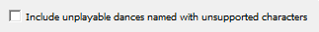

Include unplayable dances with unsupported characters: Why use this? Some users may prefer seeing in the Player's display panel what files still need to be corrected. Also, the Player's error reporting after Utilities/Recheck Database
[Cntl-R] gives more specific details on how to fix each entry. Recommended.
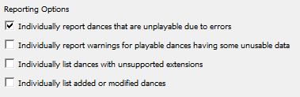

Reporting options control the information written to the MITMacroReport.txt file. Highly recommended for solving issues.
- That's it! Enjoy your MITPlayer to the fullest extent. To learn how to set up configuration options and the Player's most useful features, read the documentation: info.mit.new.users and info.mit.group.communications.
You can always contact me via the email shown on the MITPlayer page or Google "MITPlayer".
Thanks!
Murray (on behalf of the MITPlayer Team)

ID3 tags store information such as title, artist, album, track number, duration, etc within the file itself. The information is typically entered manually via an external program, a batch tagger, or audio players like Winamp or iTunes.
Type that string in the address bar of the File Explorer. Or use the actual path: C:\Users\[USER]\AppData\Roaming\Mp3tag\export or C:\Users\[USER]\Mp3tag\export. (Replace [USER] with your username.)

